Hi Chelsea /  Stephanie

I just wanted to share a post I’ve made on our work intranet today about my trip to see Light Creatures last night.

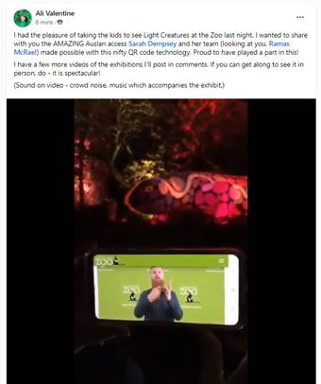

It was so brilliant to see our QR code in action! I’ve attached my little video also, showing how easily it works! I’ve asked my marketing team to share this on socials as a reminder to book tickets and use the QR code. And we have a little feature coming up in our September issue of our supporter magazine.

I wanted to let you know we are so impressed with the way you have integrated this into your execution: the code is right there, not off on a separate sign which so often happens, making the access for Deaf people separate and ‘other’.

Your team took my feedback about making sure your QR code information had Deaf consultancy on board, and the result is PERFECTION!

Ali ☺

**Ali Valentine | Group Partnerships Manager**  
  
**Can:Do Group**  
**E:**[**Alison.Valentine@candogroup.com.au**](mailto:Alison.Valentine@candogroup.com.au) **| P: 08 8100 8227 | M: 0406 355 267**59-61 Grange Road | Welland SA 5007  
**Let’s get social |** [**Can:Do 4Kids**](https://protect-au.mimecast.com/s/EA-SCr8151UxDz4T43SjZ?domain=facebook.com) **|** [**Deaf Can:Do**](https://protect-au.mimecast.com/s/D--GCvl151ivyPrtACRvE?domain=facebook.com) **|** [**Can:Do Hearing**](https://protect-au.mimecast.com/s/e4tFCwV151UoR4gT1nCuZ?domain=facebook.com) **|** [**Can:Do Group**](https://protect-au.mimecast.com/s/CTNDCxng5gtZQgPtWZz3T?domain=linkedin.com) **|** [**TinnitusSA**](https://protect-au.mimecast.com/s/CqrLCyoj5jsYyQAcP5mpv?domain=tinnitussa.com.au)

    [](https://protect-au.mimecast.com/s/eiz_Czvk5kCKmyOFMKQ3J?domain=candogroup.com.au/)    [](https://protect-au.mimecast.com/s/2MINCANpopij1PGSBFJoO?domain=cando4kids.com.au/)    [](https://protect-au.mimecast.com/s/-O9dCBNqpqivlkztQAAeq?domain=deafcando.com.au/)    [](https://protect-au.mimecast.com/s/dwZtCD1vrvuXOWDfvXFtf?domain=candohearing.com.au/)    
  
[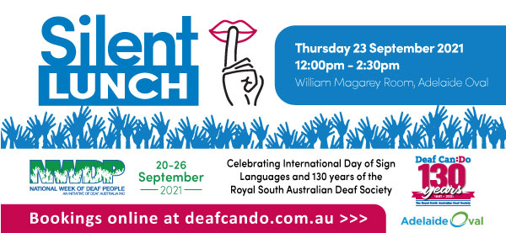](https://protect-au.mimecast.com/s/WKBYCE8wvwUB6zkSk4CaW?domain=deafcando.com.au/)   
  
If you receive this email by mistake, please notify us and do not make any use of the email.