MANCHESTER CITY COUNCIL

Family Attraction
Leisure Opportunity

September 2021
Early Market Engagement

Preliminary Market Consultation under Regulation 40 of The Public Contracts Regulations 2015




1. Introduction

Heaton Park is a regional destination park, whose spirit is evoked through its stories of music, sport and escape from the city. Celebration, recreation and relaxation at Heaton Park unite the many generations of visitors that have enjoyed the Park as a private and then public space. The theme for the Spirit of Place is: Innovation and boldness; recreation and escape.

The provision of top-quality activities and services in Heaton Park is vital to the improvement and development of the Park’s visitor facilities, adding to the visitor experience and helping to turn a good visit into a great one. Heaton Park attracts a large number and wide range of visitors from across the north west region and beyond; we want to introduce a vibrant, modern approach that reflects this diversity and works hard to fulfil the needs of all our visitors.

We are preparing to present to the market the opportunity to play a key part in an exciting new facility as we seek to create a new family attraction at Heaton Park. This is an early market engagement exercise prior to a formal tender process.

Important information

This process is intended to inform the Council’s understanding of the market and is not part of a formal procurement process. Should the Council decide to proceed, a formal procurement process may follow at a later date. Any responses received will not preclude any person or organisation from participating or being involved in any future procurement process. All information provided as part of this exercise will be freely available to all parties involved in any future procurement exercise. Local authorities are subject to the Freedom of Information Act 2000 and cannot guarantee that information received will remain confidential.

2. Overview

Manchester’s Heaton Park is one of Europe’s largest public parks, and is situated at the heart of one of its most densely populated urban communities. The Park has the capacity to be many things to many people, because of its position – just four miles from the city centre, its size – 240 hectares (640 acres), its proximity to major road networks, its rich social heritage, and the multitude of diverse local communities it serves.

Heaton Park is a Grade II Registered Park and Garden on the English Heritage Register of Parks. There are nine listed structures in the Park, including its centrepiece, the Grade I listed Heaton Hall.

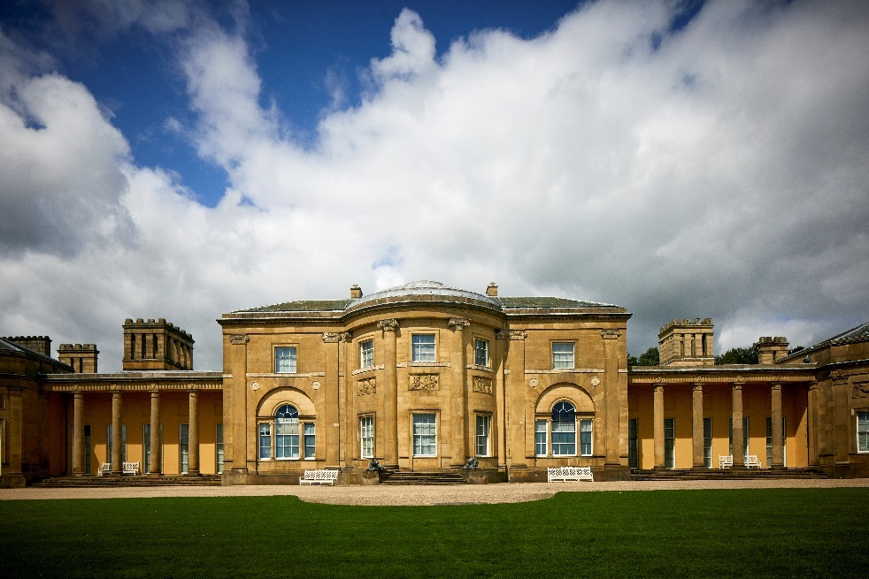

The development of Heaton Park is a major cultural regeneration project for the city and an integral part of the Parks Strategy. It is one of our best-loved parks, with some 1.8million visits per year.

Through strategic planning, this is set to increase as we improve facilities and offer additional attractions and activities. Our vision is to keep the best of the past and, through innovation, build on the spirit of this special place to make it the best park in the north west. This will be achieved through a mix of public and private investment.

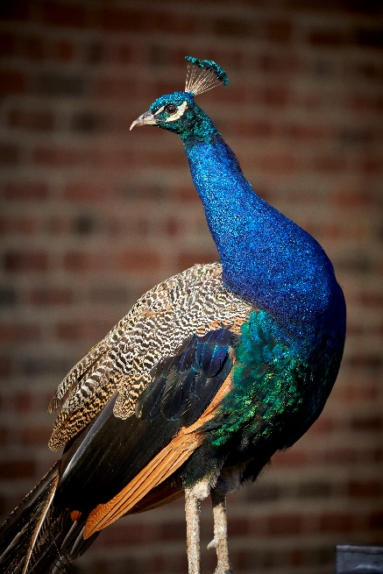

3. Future opportunity

The Council will shortly be tendering for an operating/investment partner. Prior to issuing an invitation to tender, the Council wishes to conduct market consultations (in accordance with Regulation 40 of the Public Contract Regulations 2015) with a view to preparing the procurement and informing economic operators of the Council’s procurement plans and requirements in relation to the new family-attraction facility at Heaton Park.

The Council wants to hear from potential partners who are interested in this future opportunity from an operator and investment position, as this will help us
to understand the market and to
develop the brief.


4. Site context

Manchester City Council has developed a ten-year Parks Strategy and has great ambitions for the city’s parks and green spaces that can only be fully realised through collaborative and productive partnerships with stakeholders, residents and user groups. At the heart of this strategy is a collective endeavour to both safeguard and enhance the quality of our existing parks and establish new productive and financially sustainable initiatives.
There has been a number of developments over the past six years at Heaton Park, including:
- new brand identity
- improved entrance and way-finding signage
- establishment of stakeholders’ forum
- new Facebook page
- refurbished playground
- improved catering offer
- events and theatre programme
- Treetop Trek and Nets adventure facility
- creation of second play area – Lakeside Adventure
- creation of a commemoration to the Battle of the Somme.

Heaton Park’s location makes it easily accessible (see appendix 1 – Visitor Map). It is well served by its own Metrolink tram station, linking it directly to the city centre and beyond, and is located adjacent to the M60 Manchester Ring Road. A visitor survey in 2015 showed that 87% of current visitors live within ten miles of the Park. Our challenge has been to attract a wider demographic that will enjoy a wider range of activities and stay for a longer period of time.

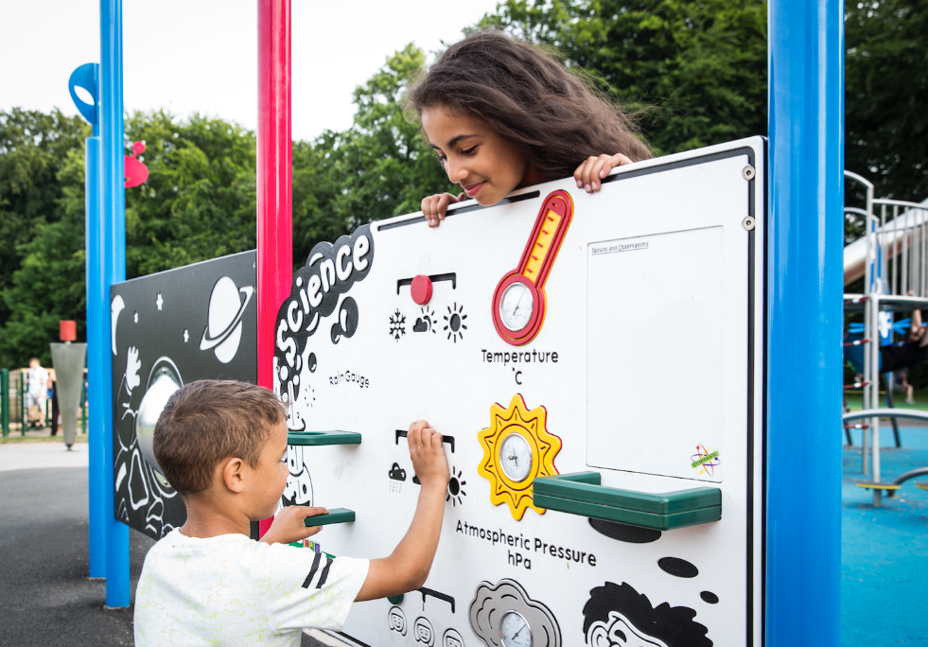

Heaton Park is an award-winning park; awards include the Green Flag Award, the Green Heritage Award, and two Community Green Flag Awards for the Beekeepers and Tramway. In addition, the Beekeepers and the Tramway have both received the Queen’s Award for Voluntary Service, a prestigious lifetime award, which is the equivalent of an MBE for voluntary groups.
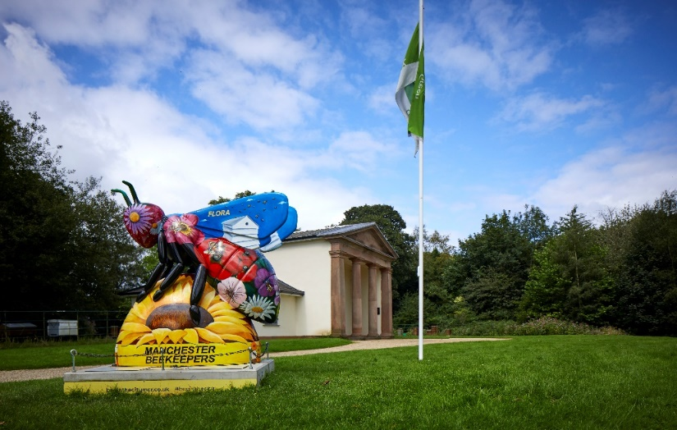

Our Heaton Park Stakeholder Forum brings together our commercial and voluntary partners who work together to develop the Park and offer a range of services and activities for our visitors:

Community and voluntary

- Friends of Heaton Hall
- Heaton Park Tramway
- Manchester and District Beekeepers Association
- Heaton Park Astronomy Group
- Heaton Park Bowls (Flat Green and Crown Green)
- Incredible Edible
- Woodland Management Volunteers
- Feelgood Theatre Productions
- Heaton Park Dog Walkers.
Commercial

- Boats
- Garden Centre and the Hidden Gem Café
- Ice cream
- 18-hole Golf and Pitch and Putt course
- Golf Café
- Lakeside Café
- The Stables Café
- Treetop Trek.

Manchester City Council/Heaton Park has a contract with Parklife, a two-day summer music event that attracts approximately 150,000 visitors. In 2016, the Park hosted the Somme 100, an event that put the Park and the city on the national and international stage. A Somme monument was installed in the Park in 2017.

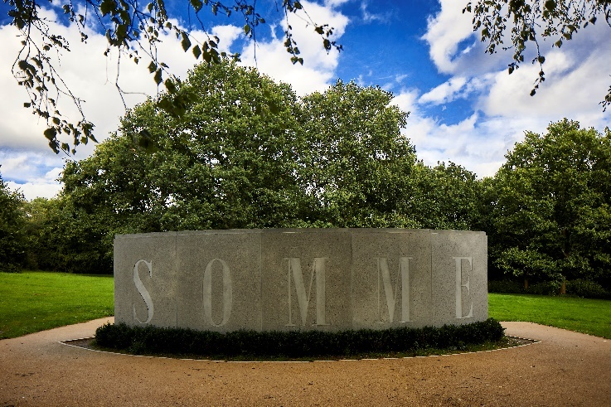

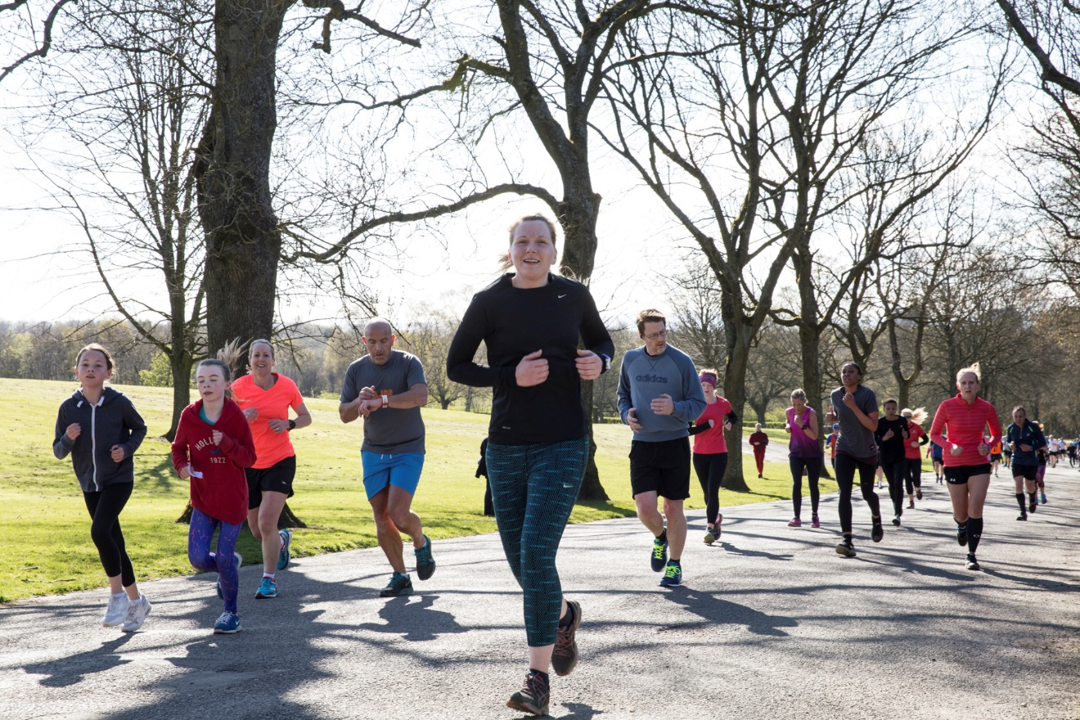

The Heaton Park run is among those with the highest attendance records in the UK. We regularly attract some 800 runners each week because of our reputation for a great 5K course and a warm welcome.

  - Nature and location of family attraction
Working with T3 Creative Agency, a new family attraction at the Park has been considered. An assessment of the best location was determined, and a consultation made with planners.

An options appraisal was completed cognisant of the constraints of a listed landscape and the green belt status of the Park. The Lakeside location was agreed to be the preferred option, as it offered more scope to develop with heritage constraints, has a high footfall, is easily accessible, and is close to one of the six car parks within the site. The site currently consists of a free-to-access ‘lakeside adventure’ woodland play area installed in 2019 (shown below), a café, a boathouse and a tram shed (see appendix 2 for the potential family zone and illustrative plan).

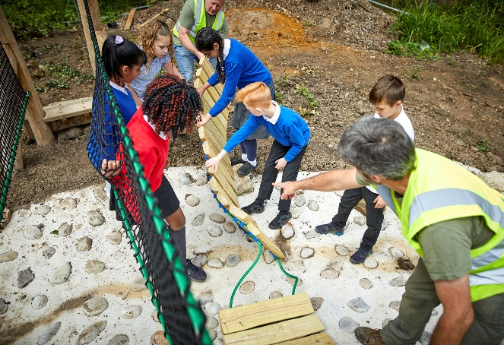
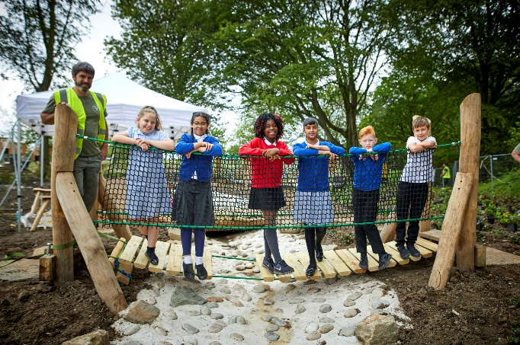

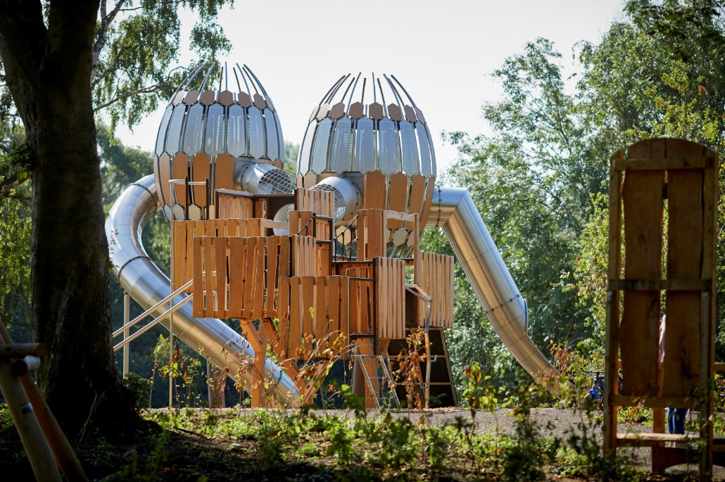

The concept of the family attraction is to provide an outdoor and indoor play/education offer on-site that would operate throughout the year, complementing and enhancing the existing offer to the public.

Heaton Park currently has no indoor activity provision for the public to access (with the exception of the Farm Centre classroom, which has a limited offer). The introduction of an indoor play facility would significantly improve the autumn/winter offer and would help to sustain footfall through inclement weather.

It is envisaged that the family attraction would:

- incorporate the existing Lakeside-built environment (Lakeside Adventure Playground, Lakeside Café and boathouse), which will be partly repurposed for indoor play and an improved food and beverage offer

- include the creation of outdoor walkways and boardwalks to complement the woodland and existing play area

- include a merchandise offer with children's parties/bookings

- provide a portion of its offer as free play (at the point of access to the public)

- be sympathetically designed in conjunction with the existing tram sheds, which could also be developed in the future

- be designed to be sympathetic to the Heritage landscape and the green belt status of the Park with the aim of safeguarding and improving the ecological environment and ongoing management of the site throughout the development and in the future.

  - Preliminary market consultations and funding queries

Manchester City Council wishes to consult the market on the best way to procure an operator to design, build, operate and maintain the new family attraction and to generate income from the facility.

6.1 The Council would value advice from market participants within the leisure industry regarding the proposed options for funding the capital costs, and wishes to understand market participants’ preferred financial arrangements for funding and views on the following two proposed options:

- Option A: Manchester City Council and the operator share the capital costs 50/50. Up to £2.5million of capital investment is available through the Parks Development Programme workstream 4. In line with the funding criteria, any applicant would need to match-fund up to 50% capital with their tender bid. The family attraction is expected to generate a minimum return on investment of 10% annually.

- Option B: The operator funds the capital costs – contract arrangements to be determined.

6.2 The Council anticipates that the opportunity for the use and operation of the Lakeside Adventure Playground, Lakeside Café and boathouse will be framed within a concession contract agreement to be entered into between the Council and the operator, with various performance management clauses incorporated within it. We would expect the Council to receive an annual financial return throughout the term of the concession agreement.

The Council would welcome views from the market as to whether these outline proposals are attractive.

Feedback from this enquiry will inform the brief for the future invitation to tender. Part of a public procurement exercise and advice received by the Council from the leisure industry as part of this preliminary market consultation may be used in the planning and conduct of the procurement exercise.

In order to help you understand the proposal there is an opportunity to view the proposed site on:

Wednesday 29 September
Thursday 30 September
Friday 1 October
Tuesday 5 October
Wednesday 6 October

Please contact Steven Taylor, Commercial and Business Development Lead, to book an appointment.

Email address: steven.taylor@manchester.gov.uk
Telephone number: 07540 062 946

Documents to be returned

This early market engagement is being undertaken to consider the options available within the market for a future family attraction opportunity. Please complete and send the Response Form – appendix 3 to Vicky Cheung, Heaton Park Development Project Manager.

The closing date for responses is Friday 29 October at 4pm.

Responses are to be emailed to vicky.cheung@manchester.gov.uk and not returned via the Chest electronic tendering portal. Should you have any queries, please contact Steven Taylor.

Appendix one

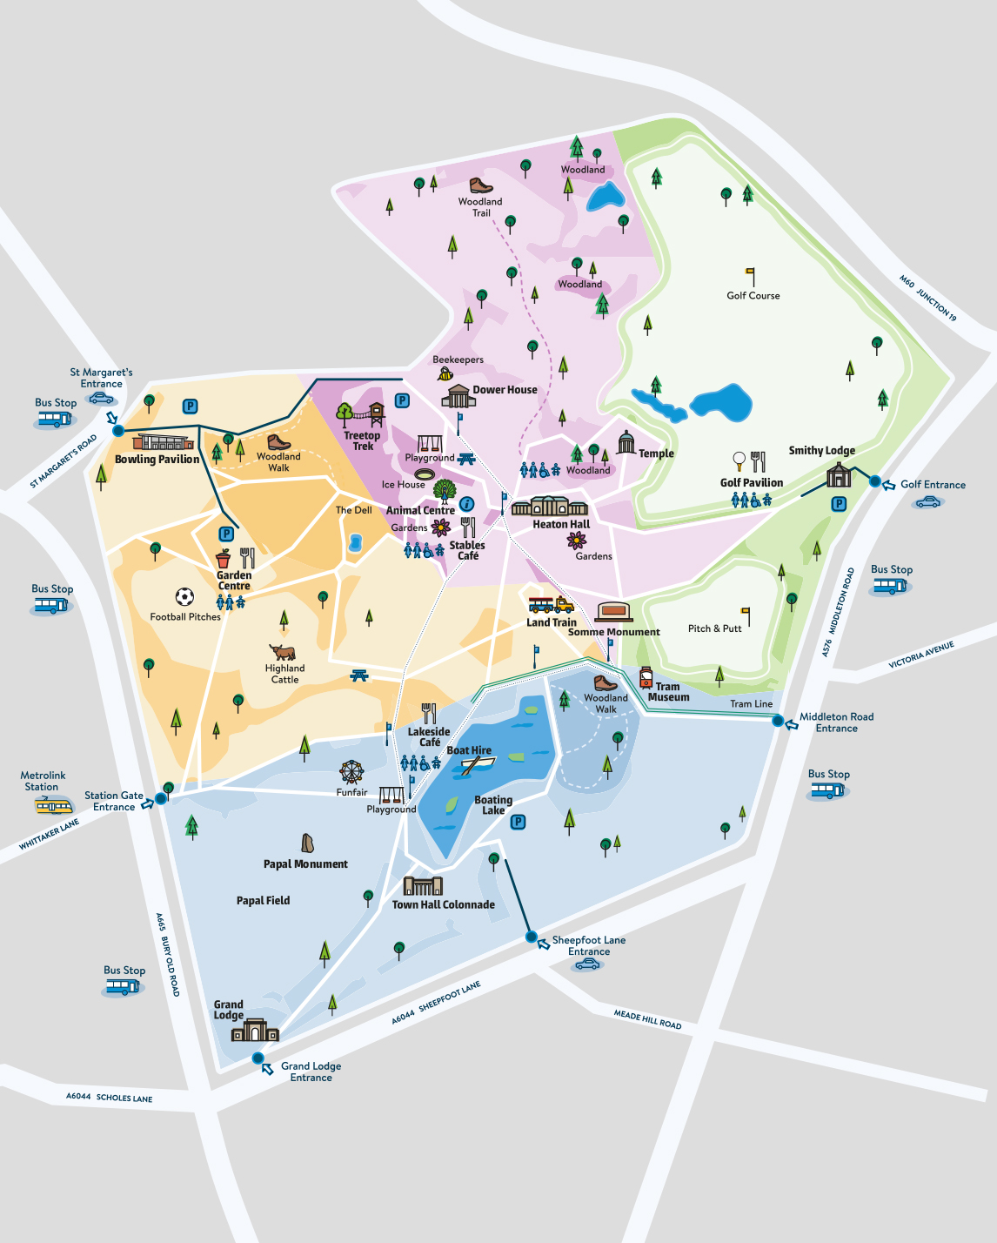

Appendix two
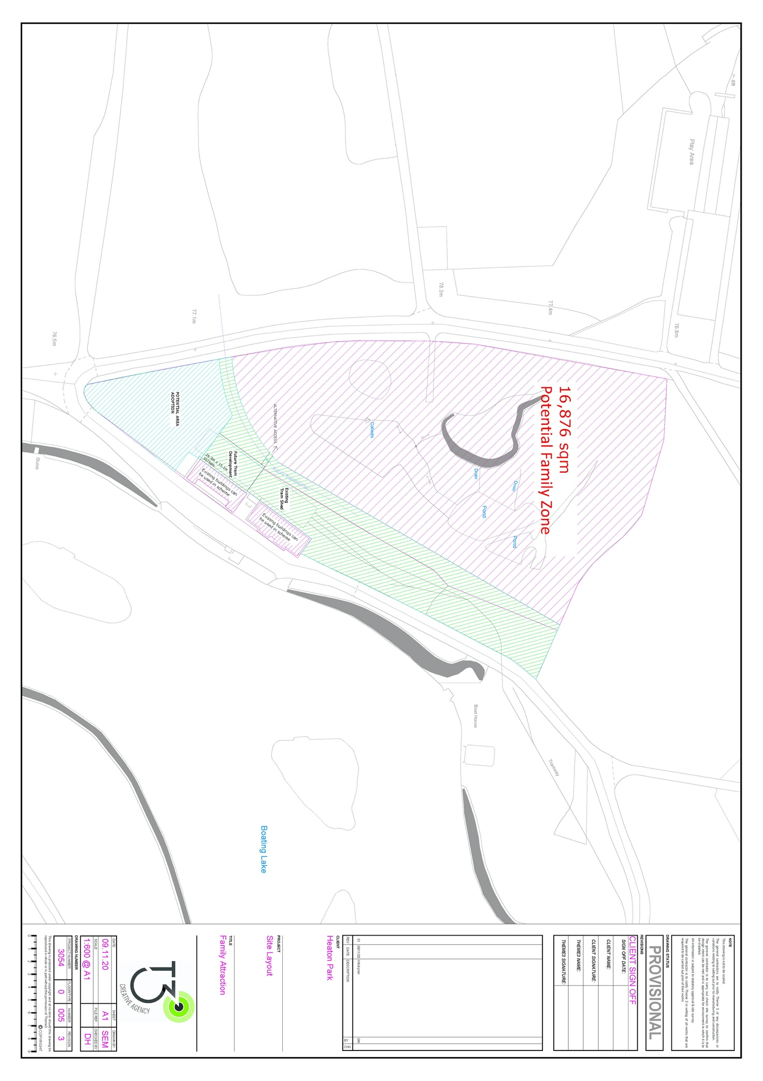

Appendix 3
Response Form

As part of this early market engagement and to shape the upcoming tender, the following questions are being asked:

Contact name:
Name of organisation:
Phone number:
E-mail address:
Date:
1. | Please set out the preferred financial option (A or B) and whether you feel there is an opportunity to generate an ongoing revenue return to Manchester City Council.
2. | What type of contract would you expect from the Council and what length of term do you envisage?
3. | Please provide a high-level financial proposal, e.g. key lease terms, rent-structure options etc.
4. | If responsibility for assets, repairs and maintenance is a 50/50 joint investment, what would your expectation be (of the Council) for assets, repairs and maintenance of the facility?
5. | What and how much involvement and control would you expect from the Council in the operation and strategically?
6. | Other comments you wish to provide:

Please return this form to: vicky.cheung@manchester.gov.uk

